Replicated Code:

Replication of code in GUI layout setup:

Here in these GUI classes components are replicated like labels, text fields, buttons and their properties (like size, position, color, font type) the only variation that is there is their placement in the code and their content in the code, while the overall structure remains the same in all these classes.

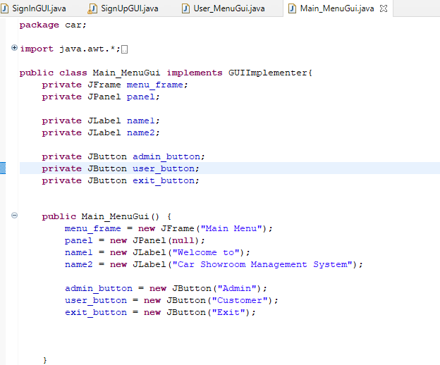

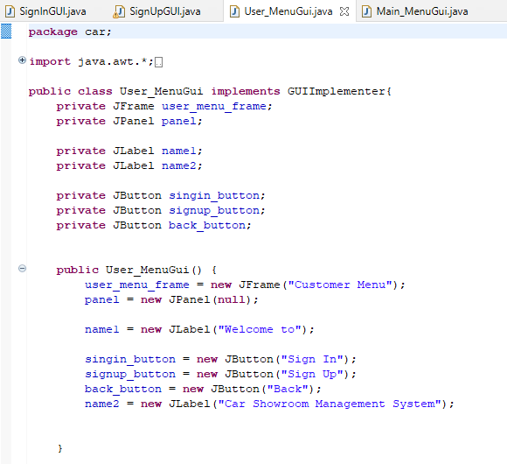

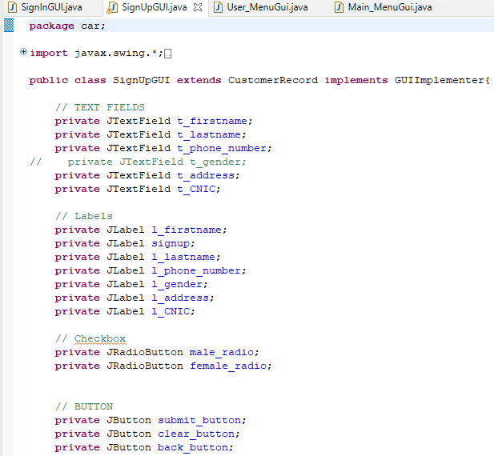

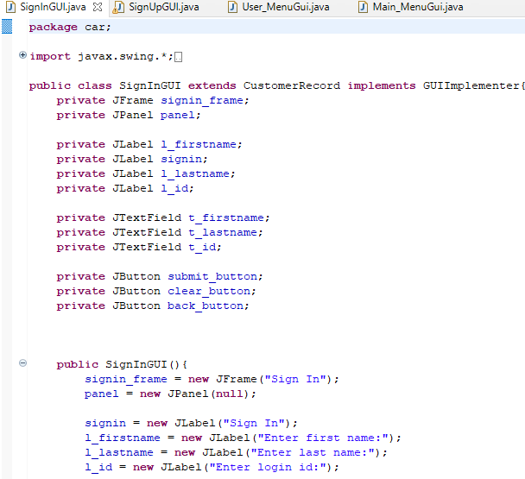

Replication of code in Event Handling:

Event handling for buttons is replicated in these GUI classes, events for buttons (like submit, clear, back) is implemented in the same way in all these classes. For example the actionPerformed method is implemented in the signInGUI,java class that handles the button click and take corresponding actions after checking the event source. The same logic is implemented in different places in these classes.

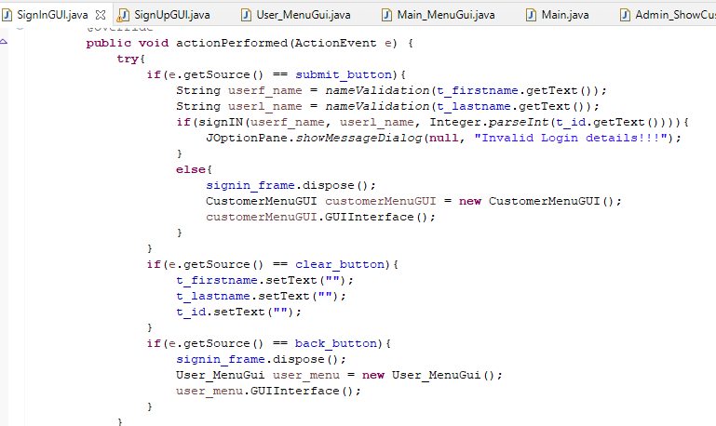

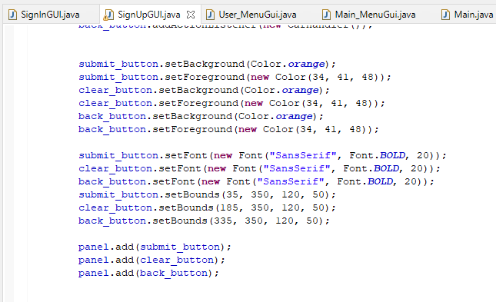

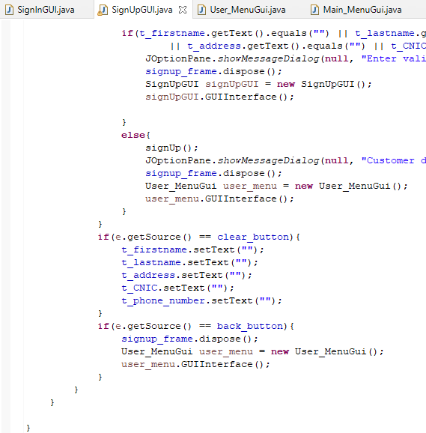

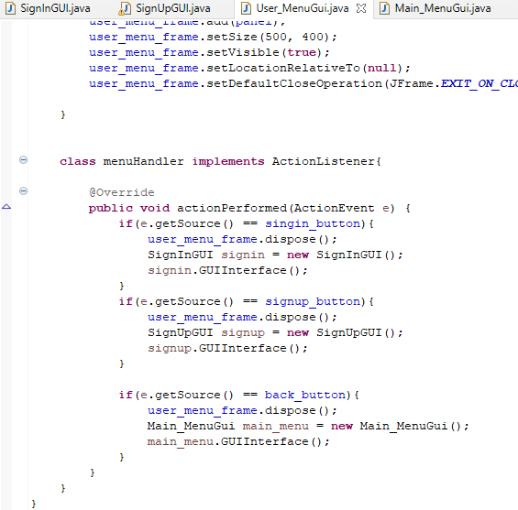

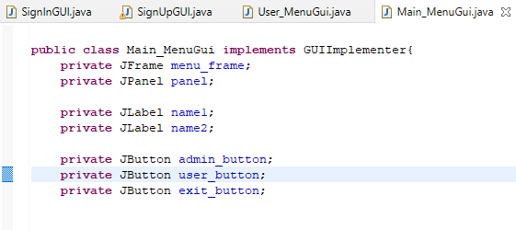

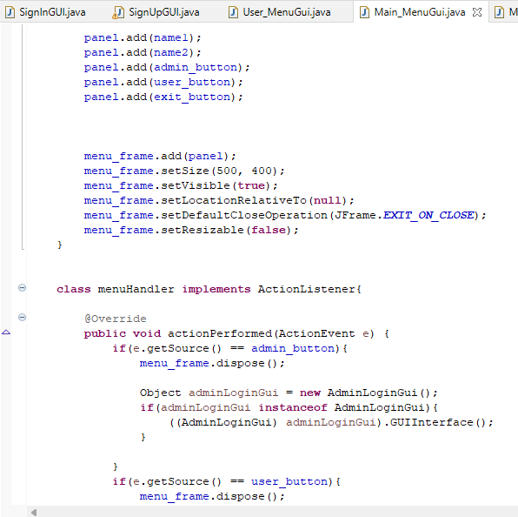

Replication of code in File Handling:

The code in file handling in reading and writing to files example in (booking cars.txt and cars.txt) is present in different classes. The code is similar in these classes for example (ShowBookedCarsGUI, ShowCar, ShowCarGUI) the code present in these classes like for opening files, reading data from these files, and for processing and displaying and then manipulating this data the code for all these is quite similar in the above mention classes.

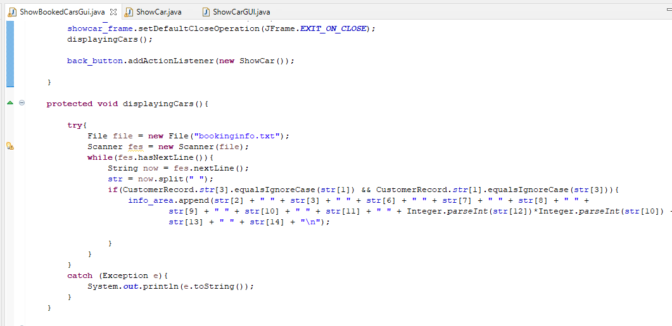

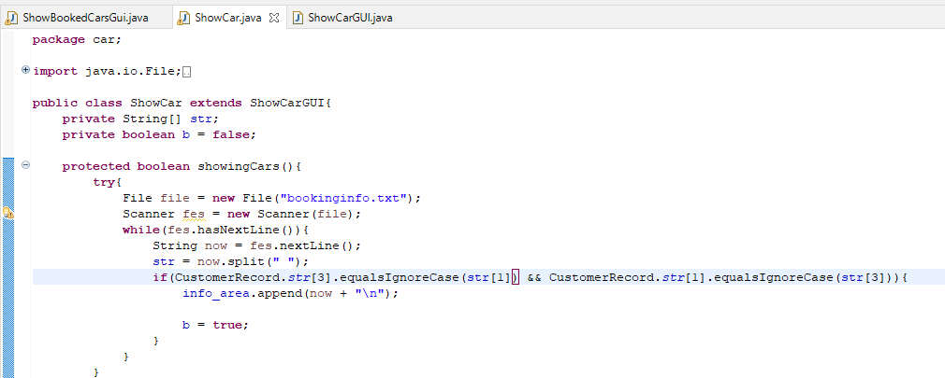

Replicated code for customer data validation:

Customer data for example (first name, last name, phone number, CNIC) the validation logic for this implemented almost same in these classes (SignInGUI, SignUpGUI). This replication includes validating the input formats, and displaying errors, and checking for empty fileds. Almost similar validation requirements are present in both classes.

